Day 12 - 27th June 2025

PENTAKOTA SAIKUMAR

Task 1

What do you understand about data structures?

IT is a ways of organizing and storing data in a computer so that we can access modify easily which helps manage large amount of data for tasks such as searching sorting and indexing

TASK 2

What are the types of data structures you know .. list them out..?

Arrays linked list stacks queues hash tables trees graphs heaps sets maps

TASK 3

What all operations can we do in Data structures?

Insertion deletion searching sorting traversing updating merging splitting

TASK 4

What are static and dynamic arrays? Explain or summarize key points in a table like

Static array dynamic array

Size fixed at declaration can grow at runtime

Performance fast access and storage slightly slow due to resizing

Memory allocated once may reallocate during growth

Flexibility less flexible more flexible

Limitations waste memory if size is large slower insertion at times

TASK 5

What is the binary value of a?

As ASCII value is 97.

97 / 2 = 48 remainder 1

48 / 2 = 24 remainder 0

24/ 2 = 12 remainder 0

12 / 2 = 6 remainder 0

6 / 2 = 3 remainder 0

3/ 2 = 2 remainder 1

2 / 2 = 0 remainder 1

Binary value of a is 1100001

TASK 6

Types of Computer memory with examples.. Explain ..

RAM READ ACCESS MEMORY

**ROM:** ROM full form is Read Only Memory. ROM is a non volatile memory and it is used to store important information which is used to operate the system.

TASK07

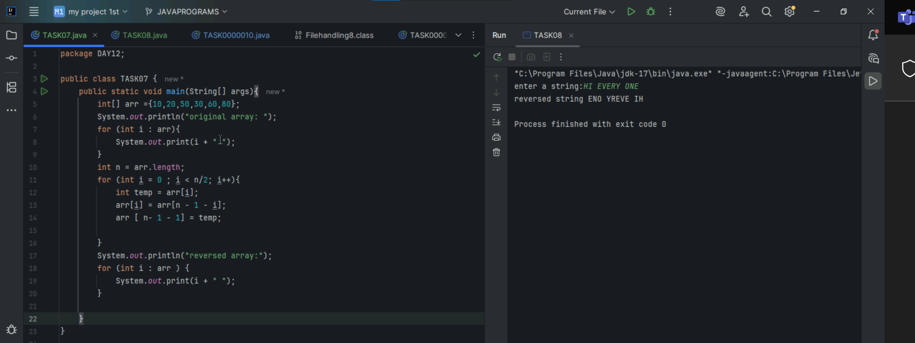

TASK08

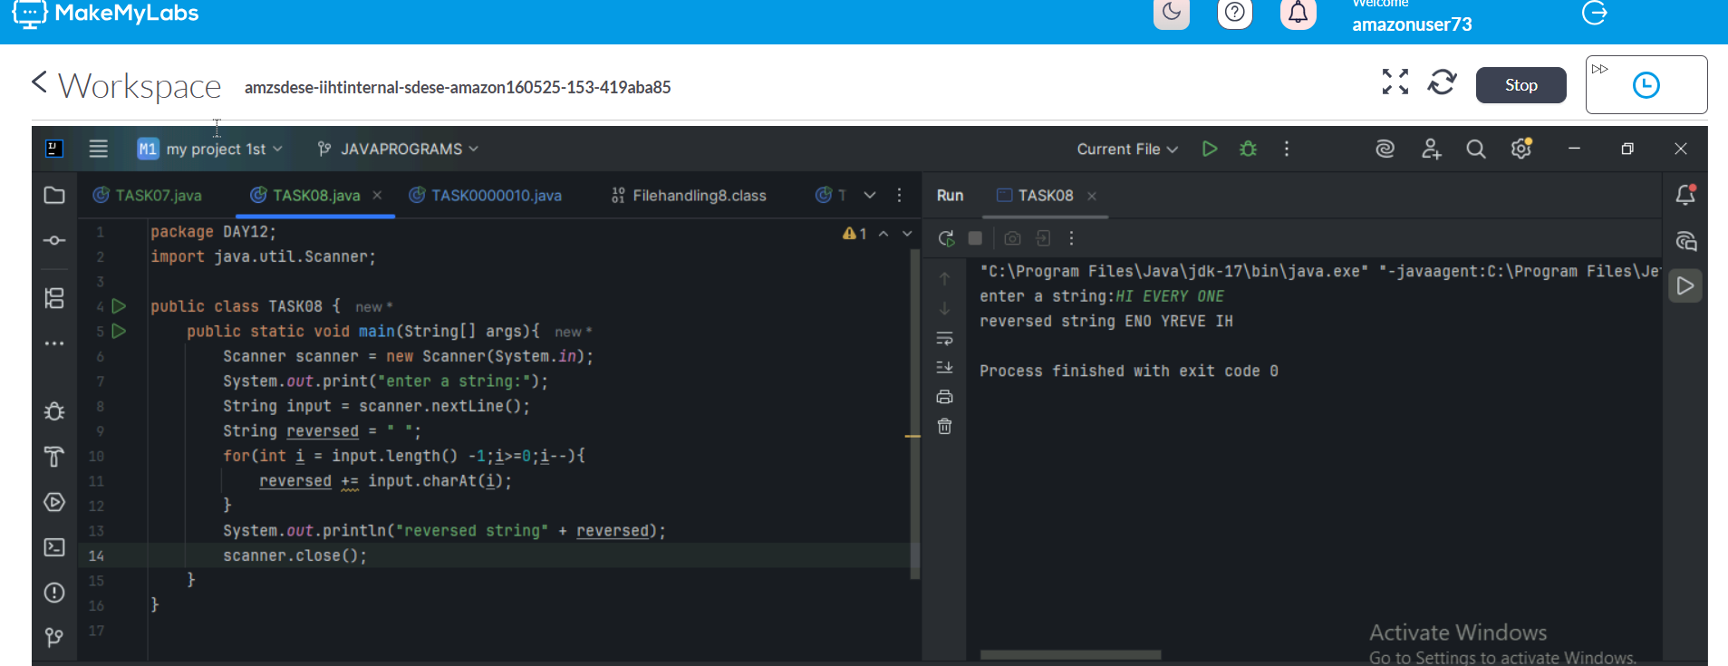

What do you understand by Hash table?

A hash table is a data structure that allows you to store and retrieve data efficiently using hashing which is used to implement associative arrays or maps where data is stored in key value pairs

